TECHNOLOGY STACK
MERN Architecture, Tools, and Rationale
MERN Full-Stack Web Application
MongoDB • Express.js • React.js • Node.js

1. Overview
The Movie Booking System uses the MERN stack: MongoDB for data storage, Express.js and Node.js for server-side APIs, and React.js for the browser interface. Additional libraries and services are selected to support routing, authentication, validation, testing, and deployment. Tools listed as optional should be included only if used by the project.
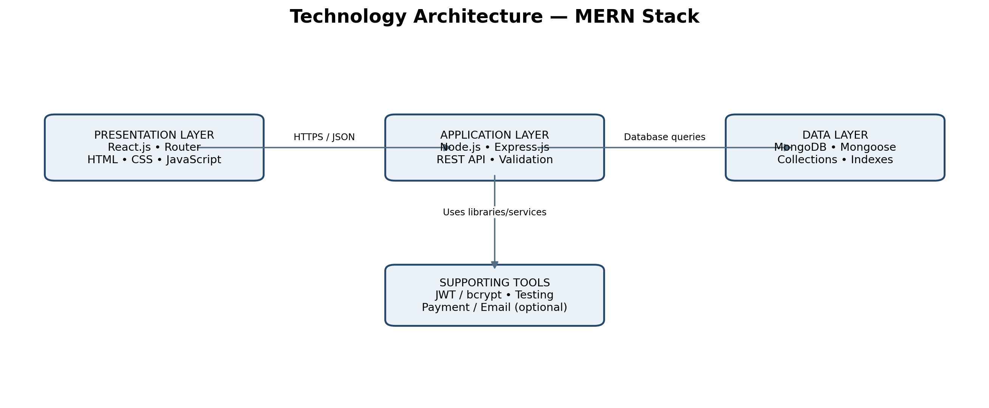

2. Core MERN Components
Component | Technology | Role in this project | Why it fits
Frontend | React.js | Renders movie listings, movie details, seat selection, checkout, booking history, and admin screens. | Reusable components and state-driven interactive UI.
Backend runtime | Node.js | Executes server-side JavaScript and handles API requests. | One language across frontend and backend.
Backend framework | Express.js | Defines REST routes, middleware, validation, authorization, and error handling. | Lightweight routing and middleware ecosystem.
Database | MongoDB | Stores users, movies, cinemas/screens, shows, seats/reservations, and bookings. | Document-oriented storage fits evolving application records.
Data modelling (if used) | Mongoose | Defines schemas, validation rules, and queries for MongoDB. | Centralized model definitions and validation support.

3. Frontend Technology
Technology / tool | Use | Selection note
HTML5 and CSS3 | Semantic page structure and visual styling. | Core web standards.
JavaScript (ES6+) | Frontend logic and API interactions. | Use TypeScript only if the existing project is configured for it.
React Router | Client-side page navigation. | Useful for movie, show, booking, login, and admin routes.
Fetch API or Axios | Calls backend REST endpoints. | Choose one primary HTTP approach and handle errors consistently.
CSS Modules, Tailwind CSS, or Bootstrap | Responsive layout and reusable styling. | Choose the option already used by the project; avoid unnecessary overlapping frameworks.
Vite (recommended for new projects) | Development server and frontend build. | Use the actual build tool already present in the repository.

4. Backend Technology
Technology / tool | Use | Selection note
Node.js | Server runtime. | Use a supported LTS version compatible with dependencies.
Express.js | API routing and middleware. | Organize routes by feature and centralize error handling.
Mongoose (optional) | MongoDB object modelling. | Use if the codebase uses Mongoose; native MongoDB driver is also valid.
JWT or server-side sessions | Maintains authenticated user identity. | Choose one documented strategy; protect secrets and configure cookies securely if used.
bcrypt or Argon2 | Password hashing. | Never store plaintext passwords.
Validation library or custom schema validation | Validates request bodies, parameters, and query values. | Validate on the backend even if the frontend validates too.
Environment variables | Stores configuration and secret references. | Do not commit credentials or API keys.

5. Database Design
Collection | Main purpose | Example fields
users | Accounts and access roles | name, email, passwordHash, role
movies | Movie catalogue | title, description, genre, duration, language, posterUrl, status
cinemas | Cinema details | name, address/location
screens | Screen layout | cinemaId, screenName, seats
shows | Scheduled screenings | movieId, screenId, startTime, endTime, ticketPrice, status
bookings | Customer reservations | userId, showId, seatIds, amount, bookingStatus, paymentStatus, reference
payments (optional) | Payment references and state | bookingId, providerReference, amount, status
Create indexes for frequently queried fields such as movie title/status, show movieId/startTime, and booking userId/createdAt. The exact indexes and seat reservation strategy must be designed around the schema. Enforce seat uniqueness safely under concurrent booking attempts.

6. API and Security Stack
Area | Recommended approach
API style | REST API using HTTPS and JSON.
Authentication | JWT in a secure cookie or server-side sessions; choose and implement consistently.
Authorization | Backend role checks and ownership checks on protected endpoints.
Security middleware | Configure CORS for expected frontend origins, rate-limit sensitive routes, and use secure headers.
Input validation | Validate IDs, dates, seat identifiers, amounts, and user input on the server.
Payment integration (optional) | Use a supported provider SDK/API and verify server-side callbacks/webhooks.
Error handling | Consistent HTTP status codes and safe error response shapes; do not expose stack traces in production.

7. Development and Quality Tools
Tool | Purpose
Git | Version control and change history.
GitHub or GitLab | Remote repository, collaboration, and optional CI workflows.
Postman or Insomnia | Manual API request and response testing.
Jest or Vitest | Unit testing; choose based on the project configuration.
React Testing Library | Tests user-visible React behaviour.
Supertest | Tests Express endpoints in integration tests.
OpenAPI / Swagger (optional) | Documents API routes and request/response contracts.
ESLint and Prettier (optional) | Consistent code style and early detection of common issues.

8. Deployment and Operations
Component | Deployment option | Notes
React frontend | Static frontend hosting or a web server | Configure the production API base URL and HTTPS.
Node/Express backend | Node-compatible application host or container | Set environment variables, health checks, logs, and allowed origins.
MongoDB | MongoDB Atlas or managed/self-hosted MongoDB | Use least-privilege credentials, backups, and network access controls.
Images/posters (optional) | Object storage or image hosting service | Store stable URLs/metadata in MongoDB rather than large image files where appropriate.
Payments / messaging (optional) | Provider-managed service | Keep secrets server-side and test sandbox flows before production.

9. Typical Request Flow
- React renders the requested page and gathers user input.
- The frontend calls an Express endpoint over HTTPS and sends JSON.
- Express middleware authenticates the user, validates input, and checks permissions.
- The route/controller calls the service layer to apply booking or catalogue rules.
- The service reads or updates MongoDB through Mongoose or the native driver.
- The API returns a structured response and React updates the interface.
- Optional payment and notification services are invoked only where the implemented workflow requires them.

10. Recommended Project Structure
A practical structure is shown below. Adapt folder names to your existing repository.
movie-booking/
client/ React application
src/components/ Reusable UI components
src/pages/ Movie, show, seat, booking, and admin pages
src/services/ API client functions
src/routes/ Frontend route configuration
server/ Node.js / Express application
src/routes/ REST route definitions
src/controllers/ Request/response handlers
src/services/ Business rules and booking logic
src/models/ MongoDB/Mongoose models
src/middleware/ Authentication, authorization, validation
src/config/ Database and app configuration
src/utils/ Shared helpers and error handling
tests/ Backend tests
README.md Setup and run instructions

11. Final Stack Summary
Core: React.js + Node.js + Express.js + MongoDB. Common supporting choices: React Router, Fetch/Axios, Mongoose, secure authentication, backend validation, Git, API testing, and a suitable hosting provider. Payment, email/SMS, QR tickets, image hosting, and API documentation are optional integrations based on the real project requirements.

12. Implementation Accuracy Note
This document recommends a suitable stack for a MERN movie booking project. It does not claim every listed library or integration is already present in your source code. Before submission, retain only the tools actually used or clearly label the others as proposed enhancements.

